**Density – mass and volume!**

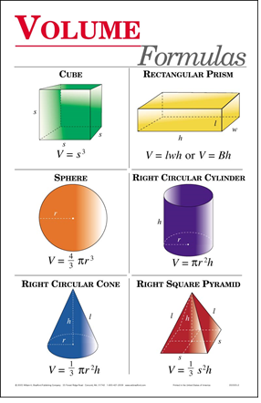**Mass:** -

* Measured in grams, kilograms etc

**Volume:** -

* Measured in ml or cm3

**Finding volume**

1. Calculate using ______________
2. Place in water and measure the _______________

**Density**

* Density is the amount of ________ within a _________.
* It is a measure of how ________________ the atoms are in an object.

**Exampl**e

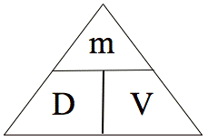**Calculating Density**

Density= **_____________________**

Mass= **_______________________**

Volume = ____________________

**Example**

Ex. If the mass of a box is 21g and it takes up 7 cm3 of space find the density.

Solve using grass method.

Use the GRASS method.

G🡪 ____________________

R🡪 ____________________

A🡪 ____________________

S🡪 ___________________

S🡪 ___________________

**Example2**

Ms K has a green pen. The pen has a mass of 8g and a volume of 2cm3. What is the density of the pen?

G

R

A

S

S

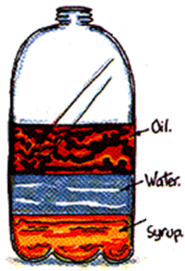

**Liquid layers**

* Liquids with different densities _____________
* The liquid with the **_________________** will be on the **__________**.
* The liquid with the ***_________________*** will be on ***___________***.

**Questions**

1. What is the formula for density?
2. What happens if you pour together liquids that have different densities?
3. Will the liquid on the top have the highest or lowest density?
4. Why does ice float on water?

**Factors affecting density**